Democracy in Crisis: A Historical Perspective
Democracy is under threat all around the world. How did this happen?
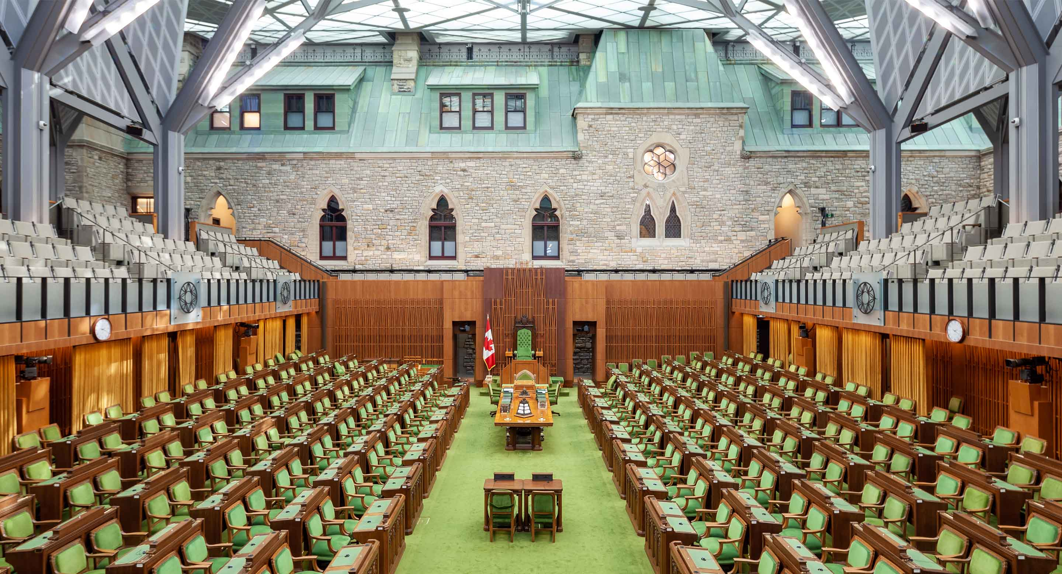To fully understand this global phenomenon, we’ll look back in time from ancient Greece to today’s digital age to examine the emergence and evolution of the system of governance designed to reflect the will of the people that is now in danger.
How did democracy originate, how did it change, what challenges did it face, and will it survive?
Saturdays, 1– 3 p.m.
Jan. 31 – Mar. 21
Hybrid course
Instructor: Olivier Couteaux

