The Greatest Scams in History: Genius, Deception, and Power
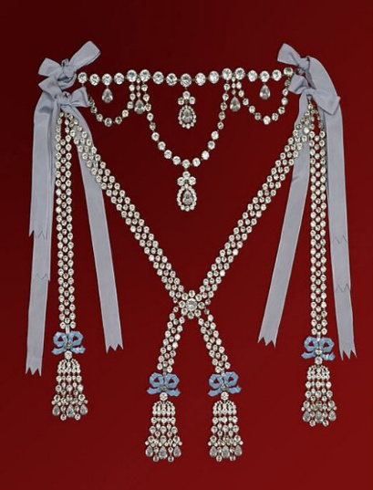
Meet the impostors who beguiled, enticed, and manipulated their way into history.
Ranging from the 18th century to today, eight fascinating case studies will reveal how some notorious con artists were able to lure and exploit their victims by playing on human emotion and desire
As more sophisticated scams proliferate, this is a
wake-up call to beware!

The Affair of the Diamond Necklace

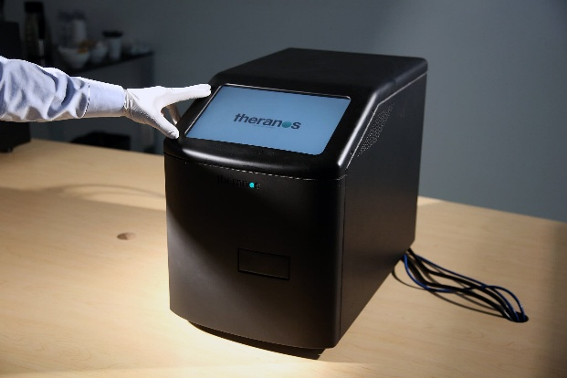
Mondays, 12:30 – 2:30 p.m.
Jan. 26 – Mar. 23
Hybrid course
Instructor: Olivier Courteaux

The Theranos Machine

